1. Bot will enter the URL link - <https://property.swansea.gov.uk/online-applications>

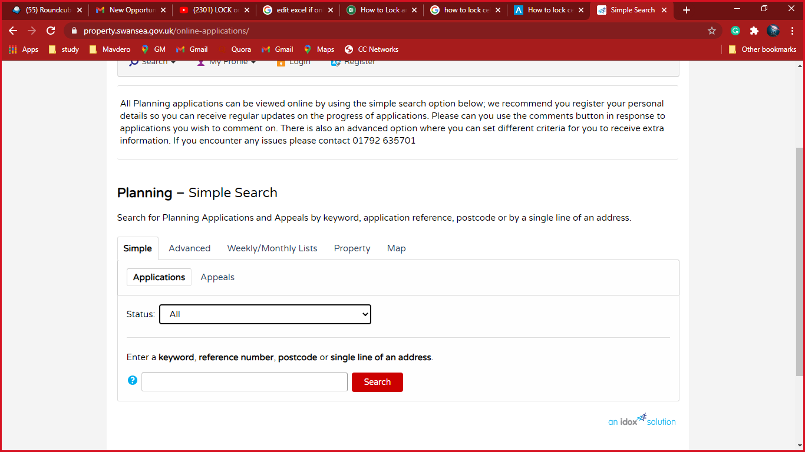

1. Bot will select the All in Status



1. Bot will enter the Address

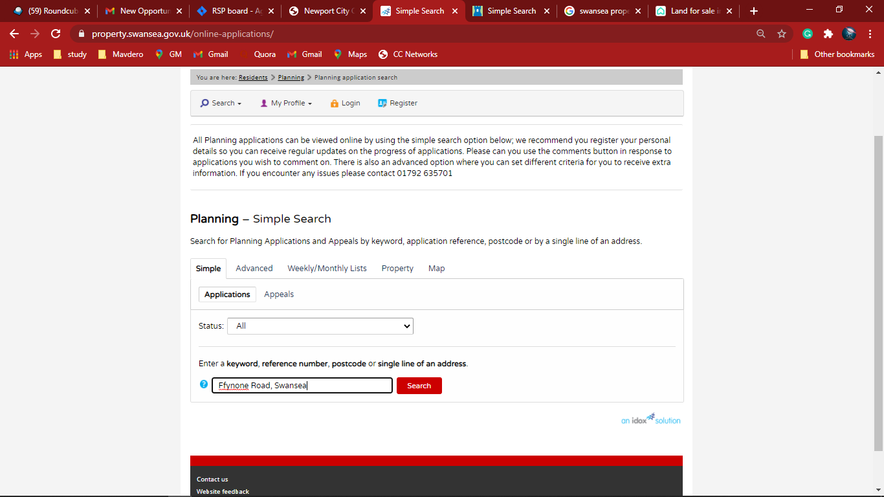

1. Bot will select the correct Address

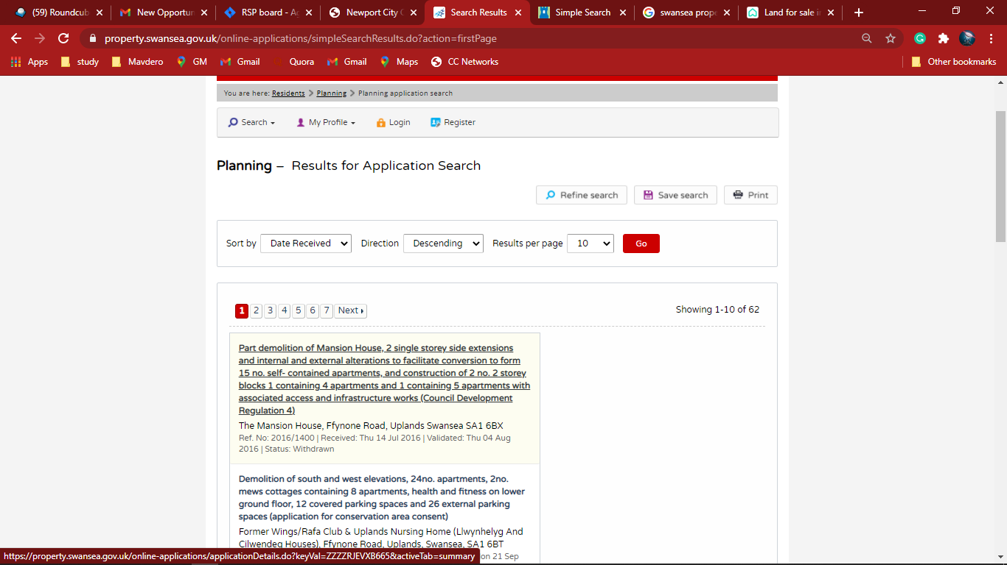

1. Bot will click the Important Dates and Application Summary of Important Dates show as follow

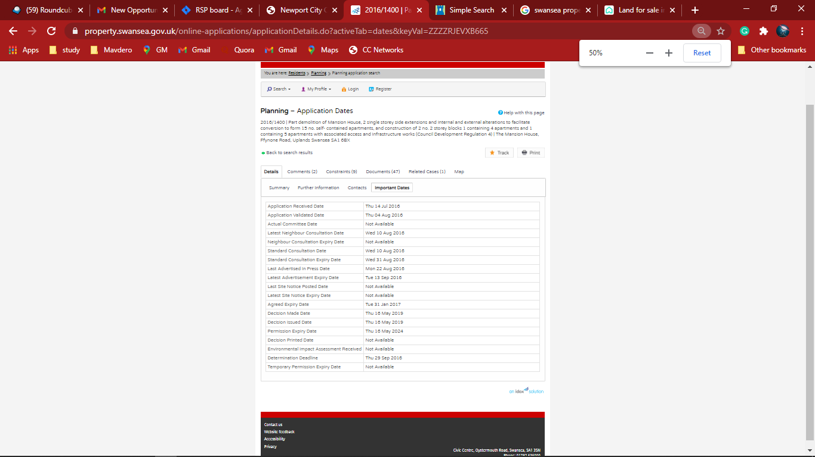

1. Bot will extract the Data from Important Data tab and populate in Excel file

